**Auteurs:** J.E Tovar Ramos, D. Frimat

**Direction:** R&D

This document is **••** CONFIDENTIAL RESTRICTED

|  |
| --- |
| **Distribution list** |

|  |
| --- |
| This document and the information contained herein is L'Air Liquide S.A. or one of its affiliates' property. The document is confidential business information and may furthermore contain confidential technical information. It is provided to certain employees of the Air Liquide group for their internal use exclusively in the course of their employment. Any reproduction or disclosure of all or part of this document to third parties is prohibited without the express written consent of an authorized representative within the Air Liquide group. If you have received this document by mistake, please immediately notify the sender and destroy the original message. |

Memo - AEL modelling

**Abstract**

The objective of this memo is to describe the calculation philosophy behind the Alkaline electrolyser tool; the sources, the equations and limitations of the model.

The electrolyzer tool is a semi-empirical model that estimates the polarization curve of an electrolytic cell using the basic operating conditions and electrolyzer characteristics as input data. The stack operation is deduced by extrapolation of the cell results.

**Sources and modelling**

The two main sources of information for the Alkaline electrolyser tool were *“Mathematical Modelling and Simulation Analysis of Alkaline Water Electrolyser for Stationary Electrolyte in Atmospheric Pressure”* by A. Bhanu and Y. Ramana (1); and *“New multi-physics approach for modelling and design of alkaline electrolyzers”* by M Hammoudi et al (2).

The first paper provided the methodology and calculation approach, their structure and sources were more explicit and easier to understand than (2). But it was limited to atmospheric operation, (2) provided a wider range of temperature and the possibility to vary the operating pressure. Hammoudi (2) thermodynamic calculations are based in a previous study by R.L. LeRoy et al (3), they improve some of their equations which are the ones that are used in our tool. Many other papers and articles were used in the development of the tool, the table below lists the main bibliography:

|  |  |  |
| --- | --- | --- |
| Title | Author | Subject |
| *Mathematical Modelling and Simulation Analysis of Alkaline Water Electrolyser for Stationary Electrolyte in Atmospheric Pressure* | A. Bhanu et al | Electrolyser Modelling |
| *New multi-physics approach for modelling and design of alkaline electrolyzers* | M. Hammoudi et al | Electrolyser Modelling |
| *The Thermodynamics of Aqueous Water Electrolysis* | R.L. LeRoy et al | Thermodynamics and electrochemistry |
| *The bubble coverage of gas-evolving electrodes in stagnant electrolytes* | H. Vogt et al | Bubble behavior and effective active surface of the electrode |
| *A review of specific conductivities of potassium hydroxide solutions for various concentrations and temperatures* | R.J. Gilliam et al | KOH conductivity as function of the concentration and temperature |
| *Hydrogen Evolution and Interface Phenomena on a Nickel Cathode in 30 w/o KOH* | J.-Y. Huot | Electrochemistry. Kinetic parameters |

Bhanu (1) and Hammoudi (2) provided the core calculations, while the other papers were consulted to verify the deduction of some equations and to test some of the equations against data provided in graphics and tables.

The main difficulty to build the model was that Hammoudi (1) who provided the more comprehensive approach, was also incomplete. Some equations made reference to variables that were not explained or for which no value or equation were provided. The lack of nomenclature made very difficult to interpret this document. The deductions of the thermodynamic equations were not thoroughly explained, this led to assumptions that were not always confirmed and that sometimes were in contradiction with the results from other publications. Later the analysis of LeRoy (3) provided the necessary theoretical background and made possible to understand the definitions of (1).

The modelling of (1) and (2) are based on electrolyzers working with nickel electrodes and 30%wt KOH solution as electrolyte. This simplified the task of finding the right values for some kinetic parameters as the transfer coefficient and the exchange current density. These two values depend heavily on the characteristics of the catalyst, the electrolyte type, the electrolyte concentration and the temperature. The base values applied were found in (1) and (2) either as fixed values or as correlations adapted to the electrolyzers of each study. This data was announced by the authors as “one size fits all” values, however, when applied to other references, small differences started to show. This difference becomes more evident when the model is applied to industrial references (provided by actual suppliers).

In order to better predict the behavior of an electrolyzer it was decided to identify certain parameters that could characterize each supplier and would allow to correct the base parameters and adapt them to values closer to those of the suppliers. The identified parameters were:

Anode and Cathode transfer coefficient: 𝛼

Anode and Cathode exchange current density: i0

Bubble coverage: 𝜃

Electrolyte thickness: 𝛿

The first two represent catalyst and system kinetic properties; the bubble coverage is a physical and geometric parameter (flow speed, tortuosity, form) and the electrolyte thickness is a geometric parameter.

**Tool Input Data**

The tool is an Excel Sheet with 3 tabs: Interface, Cell Calculation and Graph. The interface is the only tab necessary to the user, it presents a table for the input data, the results and the polarization curve. The other two tabs are only for calculation purposes.

The necessary input data is presented in the following table:

|  |  |  |  |
| --- | --- | --- | --- |
| **INPUT DATA - Stack Level** |  |  |  |
| Operating parameters |  |  |  |
| Pop (min 1bar, max 200bar) | 30 | bar | Operating pressure |
| Top (min 25ºC, max220ºC) | 70 | ºC | Operating temperature |
| KOH wt% (min 0%, max 45%) | 30 | %wt | Electrolyte concentration |
| iav | 12000 | A/m2 | Maximum current density |

|  |  |  |  |
| --- | --- | --- | --- |
| Geometrical parameters |  |  |  |
| Ncell | 114 | - | Nb of cells in stack |
| A | 0.58 | m² | Cell Surface Area |
| δ | 0.00135 | m | Thickness of the electrolyte |

The thickness of the electrolyte is more a representation of the geometry of the cell than the actual layer of electrolyte between the electrode and the membrane, its value is usually between 1- 2mm. All the other values should be provided by the supplier.

Another set of values will be necessary, these values are fitting coefficients and should be determined for each electrolyzer supplier. They should be close to 1.

|  |  |
| --- | --- |
| Corrections |  |
| i0-ac coefficient (T) | 4.4 |
| α coefficient | 1.2 |
| θ coefficient | 1 |

By the time this memo is written, the i0-ac coefficient is calculated by a correlation based on the temperature so it does not require the user to determine it, the value obtained from the correlation is a multiplier used for both (another and cathode) current densities. The 𝛼 coefficient is also a multiplier used for both transfer coefficients. This is a big simplification, the exchange current densities and the transfer coefficients should vary independently on the anode and the cathode, but the way to determine all these values experimentally is unpractical for the scope of this work. While theoretically 𝛼a + 𝛼c = 1 and both should be close to 0.5 Z. Abdin (8) indicates that some works report values between 1 - 2. This indicates a faulty analysis but it does not negate the predictive capacity of the model. The values of our tool have been until now close to 0.5 for all tested cases.

**Main output values**

The following table shows the main results of the calculations at the stack level, there is also a table with more intermediate values and cell information.

|  |  |  |  |
| --- | --- | --- | --- |
| **OUTPUT DATA - Stack level** | | |  |
| Main operating values | |  |  |
| I | 12000 | A | Total current applied on the cell |
| U | 1.88 | V | Individual Cell Voltage |
| P | 2569 | kW | Power consumption |
| QH2 | 556.14 | Nm3/h | Hydrogen produced |
| Ec | 4.62 | kWh/Nm3 | Cell Electric consumption |
| ηHHV | 76.8 | % | Cell HHV efficiency |
| QO2 | 2.46 | Nm3/h | Oxygen produced |
| QH2O | 620.3 | kg/h | Water consumed |

**Sensitivity of the model**

The following graph show how a modification of each input value affects the form of the polarization curve:

**Temperature Influence:**

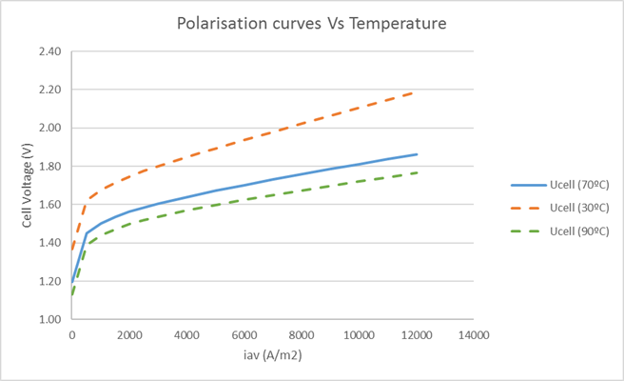

**Pressure Influence:**

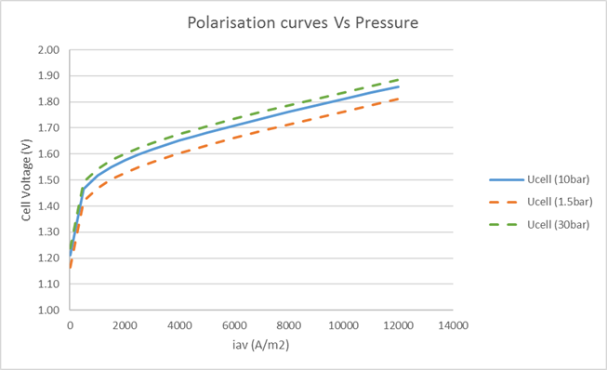

**Electrolyte Concentration Influence:**

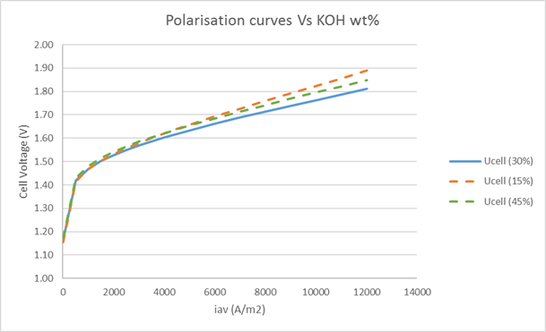

Basically, the increase of the temperature will displace the curve vertically, decreasing the voltage for a given current density. The pressure increase will have the opposite effect displacing the curve vertically. The effect of the KOH concentration is different, it has practically no effect at low current density (were the activation overvoltage is predominant), but the slope of the curve will be more or less pronounced following the conductivity of the solution which maximum is close to 30 – 35%wt.

**Influence of fitting coefficients**

**Influence of the multiplier α coefficient:**

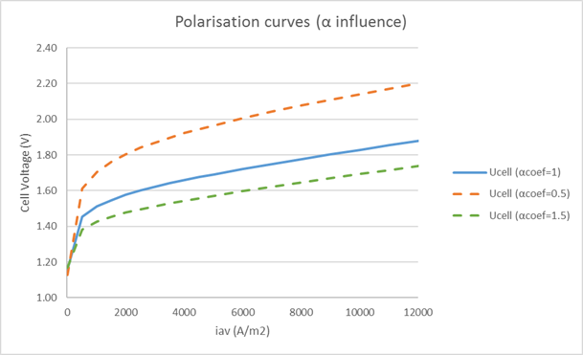

**Influence of the multiplier θ coefficient:**

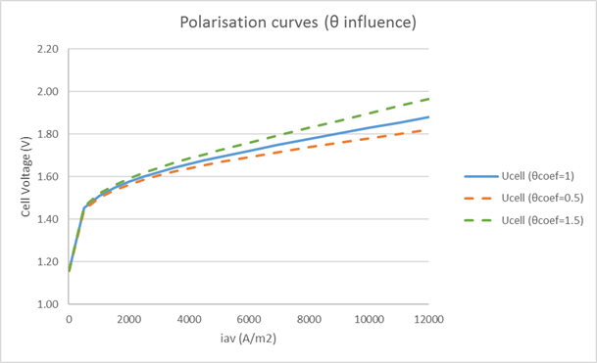

**Influence of the δ parameter:**

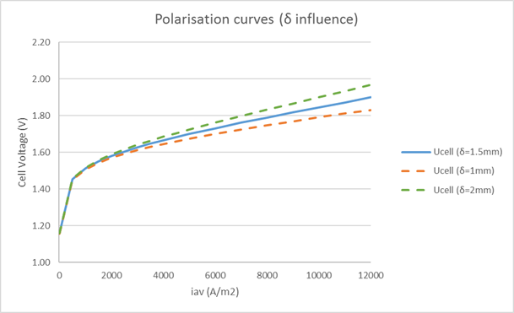

**Influence of the i0 coefficient:**

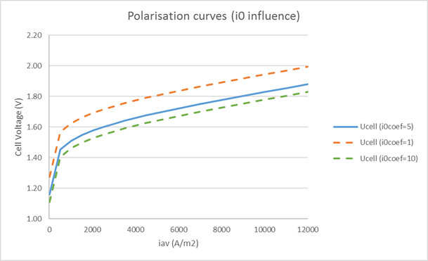

As can be observed these four parameters have similar effects: α and i0 coefficients will displace the curve vertically without changing the slope; while θ and δ will change the slope but will not displace the curve.

α and i0 coefficients main difference will be at current density values close to zero where i0 has an influence while α does not. For the purposes of our tool this range has little importance since it will be often below the lower limit of operation. It is necessary, however, to obtain good starting values for i0a and i0c in order to have a more representative correction when fitting α. The problem is that i0 varies with temperature, electrode material and catalyst and electrolyte type and concentration. For simplification the tool is provided with a correlation based on temperature applied to both i0, but there is room for improvement.

θ and δ coefficients have almost the same effect on the curve because both are related with the effort of the current to flow through the lye, but the physical justification is different. θ is an image of the bubbles blocking the active surface on the electrode, while δ is more related to the current transfer through the electrolyte. θ will be modified by the efforts of the supplier of clearing the electrode surface (by electrolyte flow, surface treating). δ will be a representation of the geometry of the system electrode + electrolyte + membrane (the easier the current goes from one extreme to the other the lower δ value).

While fitting these values to characterize one electrolyzer model or supplier, the user must have a critical approach as to which parameter could be improving or worsening.

**Thermoneutral Voltage, Stack efficiency and Faradaic efficiency**

During the development of the tool many questions were arisen related to the meaning of the Thermoneutral Voltage and the efficiency of the stack. The harmonization file (7) provided the guidelines for the global efficiency, however the thermoneutral definition is not given clear enough.

**Thermoneutral Voltage**

The definition ΔHt,P = nFVtnt,P is globally accepted for the thermoneutral voltage, however the ΔH will be different depending on what is taken into consideration. In our tool the ΔH includes the enthalpy of the solution from 25ºC to the electrolyzer temperature + the evaporation of the water + the enthalpy of formation of the water + the evaporation of the water leaving the system with the H2 and O2 as vapor. The H2 and O2 are saturated gases and the vapor water that leaves the system consumes energy, this energy will be more important the closer the water vapor pressure is to the electrolyzer pressure.

**Stack Efficiency**

The measure of the efficiency of the stack is given as the High Heating Value Voltage efficiency. Our model takes into consideration for the High Heating Value, the enthalpy of heating the solution from 25ºC to the electrolyzer temperature + the enthalpy of formation of the water.

Three other definitions for the cell efficiency are described in the harmonisation file that are more or less used depending on the type of work and the expected public, academic or industrial. These three definitions are:

Case 1:



Case 2:



Case 3:



With:

Utn : Thermoneutral Voltage

Ucell : Cell Individual Voltage

Urev : Reversible Voltage

The high heating value is not discussed in this document (7), however it is the one that is provided by the suppliers. The definition we use is:

$η_{HHV}=\frac{U_{tp}}{U_{Cell}}$

With:

Utp : Enthalpic Voltage (Voltage equivalent to the enthalpy of formation of liquid water at T)

**Faradaic Efficiency**

The Faradaic efficiency is calculated with a correlation obtained from data provided by Tijani et al (9). It is a simple correlation based on temperature and current density. The following graph shows the evolution of the Faradaic efficiency with the current density for three different temperatures.

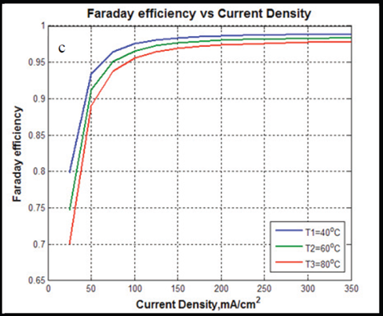

**References**

1. Bhanu kiran, A. and Ramana murty, Y.V. “*Mathematical Modelling and Simulation Analysis of Alkaline Water Electrolyser for Stationary Electrolyte in Atmospheric Pressure”* International Journal of Mechanical Engineering & Computer Applications. Vol 3, Issue 5. (Sept-Oct 2015)
2. Hammoudi, M. et al. “*New multi-physics approach for modelling and design of alkaline electrolyzers”* International Journal of Hydrogen Energy 37.19 (2012): 13895-13913.
3. [LeRoy RL, Bowen CT. “*The thermodynamics of aqueous water electrolysis*”. Journal of the Electrochemical Society 1980:1954e62.](https://drive.google.com/open?id=1rlQ-wddCt44BDuxPazEysoM_D9bbNzoT)
4. [Vogt H, Balzer RJ. “*The bubble coverage of gas-evolving electrodes in stagnant electrolytes*”. Electrochimica Acta 2005; 50(10):2073e9.](https://drive.google.com/open?id=1mImQERQh0PKELxLleNw7nwWslQ_b_UZn)
5. [Gilliam, R. J., et al. "*A review of specific conductivities of potassium hydroxide solutions for various concentrations and temperatures.*" International Journal of Hydrogen Energy 32.3 (2007): 359-364.](https://drive.google.com/open?id=1Kpc1UN3rzeqBzcBsTqM7_gBaymq0xPeO)
6. [Huot, J‐Y. "*Hydrogen Evolution and Interface Phenomena on a Nickel Cathode in 30 w/o KOH I. Kinetics Parameters and Electrode Impedance Between 303 and 363 K.*" Journal of The Electrochemical Society 136.7 (1989): 1933-1939.](https://drive.google.com/open?id=11OjJrrdhirkfe5pdr5R9HML1vXCi8RXw)
7. Tsotridis G. and Pilenga A. “*EU Harmonised Terminology for Low Temperature Water Electrolysis for Energy Storage Applications*”. Technical report by the Joint Research Centre (JRC), the European Commission’s science and knowledge service. Rolling Plan 2017.
8. [Abdin, Z. et al. “*Modeling and simulation of a proton exchange membrane (PEM) electrolyser cell*” International Journal of Hydrogen Energy 40. (2015): 13243-13257](https://drive.google.com/open?id=1mE2_W0A15v8OBjHy-qfZPoW1Jx6Kx-xC)
9. A. S. Tijani, N. A. B. Yusup, and A. H. A. Rahim, "*Mathematical Modelling and Simulation Analysis of Advanced Alkaline Electrolyzer System for Hydrogen Production*," Procedia Technology, vol. 15, pp. 798-806, 2014.